

DSP Assignment #3

|  |  |  |
| --- | --- | --- |
| Name | Section | BN |
| Ahmed Radwan GadELRab | 1 | 12 |
| Mohamed Ismail Amer | 3 | 42 |
| Moamen Nasser Saad | 3 | 37 |

Submitted to: Dr. Mohsen Rashawn

**Confusion Matrix for K-means [16 Cluster per class and DCT]**

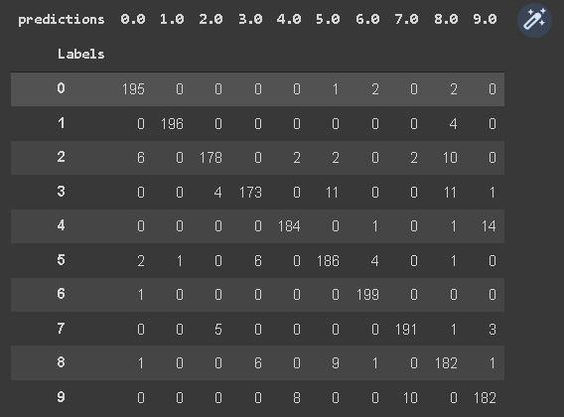

**Confusion Matrix for GMM [4 Cluster per class and LDA]**

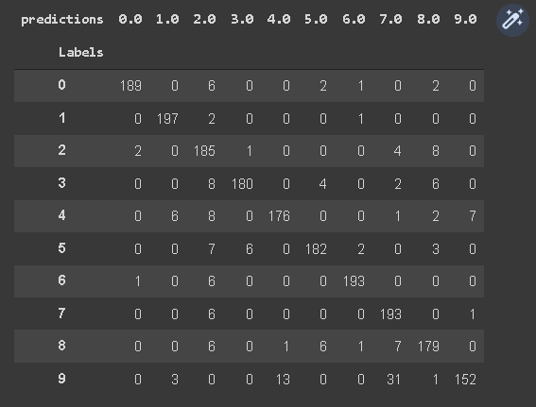

**Confusion Matrix for SVM [RBF kernel and PCA]**

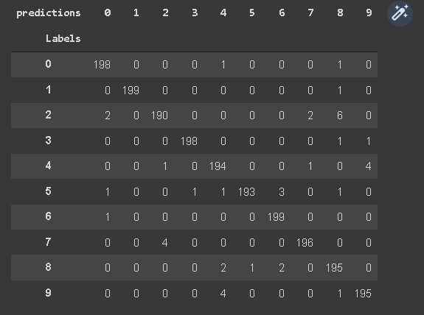

|  |  |  |  |  |  |  |  |
| --- | --- | --- | --- | --- | --- | --- | --- |
|  | |  | | Features | |  | |
| DCT | | PCA | | Your features | |
| Accuracy | Processing Time | Accuracy | Processing Time | Accuracy | Processing Time |
| Classifier | |  |  |  |  |  |  |
| K-means  Clustering | 1 | 62.85% | 2.15 s | 67.05% | 1.8 s | 89.45% | 0.15 s |
| 4 | 86.5% | 4.2 s | 88.25% | 4.3 s | 89.25% | 1.22 s |
| 16 | 93.3% | 11.1 s | 93% | 8.94 s | 90.2% | 2.5 s |
| 32 | 95% | 18.23 s | 95.35% | 14.96 s | 91.5% | 4.13 s |
| GMM | 1 | 62.1% | 32.26 s | 50.3% | 19.45 s | 86.3% | 2.27 s |
|  | 2 | 75.9% | 32.01 s | 67.55% | 28.2 s | 85.15% | 5.41 s |
|  | 4 | 85.2% | 74.6 s | 80.9% | 51.85 s | 88% | 9.81 s |
| SVM | Linear | 93.9% | 3.32 s | 93.35% | 3.49 s | 89.9% | 2.49 s |
|  | nonlinear* | 97.6% | 2.46 s | 97.85% | 3.66 s | 91.05% | 0.653 s |

**Notes:**

*We used LDA to extract 9 components of features.*

*We used RBF kernel for SVM.*

**CODE:**

|  |
| --- |
| *# mount drive that contain dataset #Data is on Drive* drive.mount(**"/content/drive"**, force_remount=**True**) **from** google.colab **import** drive drive.mount(**'/content/drive'**)  *# copy data from drive into colab #!cp -av '/content/drive/MyDrive/dataset' '/content/dataset'  # unzip data* **import** zipfile **with** zipfile.ZipFile(**"/content/drive/MyDrive/dataset/MNIST.zip"**, **'r'**) **as** zip_ref:  zip_ref.extractall(**"/content/drive/MyDrive/dataset/"**)  **import** glob **import** numpy **as** np train_dir = **"/content/drive/MyDrive/dataset/Reduced MNIST Data/Reduced Trainging data"** test_dir = **"/content/drive/MyDrive/dataset/Reduced MNIST Data/Reduced Testing data"** *# lists contains images paths* train_list = [] test_list = []  **for** i **in** range(10):  train_list.append(glob.glob(**'{}/{}/*.jpg'**.format(train_dir,i)))  test_list.append(glob.glob(**'{}/{}/*.jpg'**.format(test_dir,i)))  train_list = [item **for** sublist **in** train_list **for** item **in** sublist] test_list = [item **for** sublist **in** test_list **for** item **in** sublist]  *# create training and test datasets* **import** PIL **import** matplotlib.pyplot **as** plt  train_data = np.array([np.array(PIL.Image.open(fname)) \  **for** fname **in** train_list]) test_data = np.array([np.array(PIL.Image.open(fname)) \  **for** fname **in** test_list])  *# create training and test data* **import** re  train_label = np.array([x **for** x **in** range(10) **for** y **in** range(1000)]) test_label = np.array([x **for** x **in** range(10) **for** y **in** range(200)])  *# Shuffle training and test data* **from** sklearn.utils **import** shuffle  train_data, train_label = shuffle(train_data/255, train_label) test_data, test_label = shuffle(test_data/255, test_label)  *# plot first 30 images in MNIST after being shuffled* fig, ax = plt.subplots(6, 5, figsize = (12, 12)) fig.suptitle(**'First 30 images in MNIST'**) fig.tight_layout(pad = 0.3, rect = [0, 0, 0.9, 0.9]) **for** x, y **in** [(i, j) **for** i **in** range(6) **for** j **in** range(5)]:  ax[x, y].imshow(train_data[x + y * 6].reshape((28, 28)), cmap = **'gray'**)  ax[x, y].set_title(train_label[x + y * 6])  *# DCT Features* **from** scipy.fftpack **import** dct ,idct  **def** dct_(a):  **return** dct(dct(a.T, norm=**'ortho'**).T, norm=**'ortho'**)  **def** zigzag(a):  x=np.concatenate([np.diagonal(a[::-1,:], i)[::(2*(i % 2)-1)] \  **for** i **in** range(1-a.shape[0], a.shape[0])])  **return** x[0:200]  **def** idct_(a):  **return** idct(idct(a.T, norm=**'ortho'**).T, norm=**'ortho'**)  **def** get_dct_features(a):  DCT_features=np.zeros((a.shape[0],200))  **for** i **in** range(a.shape[0]):  DCT_ordered = zigzag(dct_(a[i]))  DCT_features[i] = DCT_ordered   **return** DCT_features.reshape((a.shape[0],-1))  DCT_features_train = get_dct_features(train_data) print(**"The Size of DCT features for Training are now {} "**.format(DCT_features_train.shape)) DCT_features_test = get_dct_features(test_data) print(**"The Size of DCT features for Testing are now {} using "**.format(DCT_features_test.shape))  *# PCA Feature* **from** sklearn.decomposition **import** PCA **from** sklearn.cluster **import** KMeans  pca = PCA(0.9) pca.fit(train_data.reshape((train_data.shape[0],784))) train_pca = pca.transform(train_data.reshape((train_data.shape[0],784))) test_pca = pca.transform(test_data.reshape((test_data.shape[0],784))) print(**"The number of components for 90% varinace is "**, pca.n_components_)  *# LDA Features* **from** sklearn.discriminant_analysis **import** LinearDiscriminantAnalysis **as** LDA  lda = LDA(n_components=9) lda_train = lda.fit_transform(train_data.reshape((train_data.shape[0],784)), train_label) lda_test = lda.transform(test_data.reshape((test_data.shape[0],784)))  *# Kmeans* **def** pred_labeled(y_true, y_pred):  y_voted_labels = np.zeros(y_true.shape)  labels = np.unique(y_true)  ordered_labels = np.arange(labels.shape[0])  **for** k **in** range(labels.shape[0]):  y_true[y_true==labels[k]] = ordered_labels[k]  *# Update unique labels* labels = np.unique(y_true)  *# We set the number of bins to be n_classes+2 so that   # we count the actual occurence of classes between two consecutive bins  # the bigger being excluded [bin_i, bin_i+1[* bins = np.concatenate((labels, [np.max(labels)+1]), axis=0)   **for** cluster **in** np.unique(y_pred):  hist, _ = np.histogram(y_true[y_pred==cluster], bins=bins)  *# Find the most present label in the cluster* winner = np.argmax(hist)  y_voted_labels[y_pred==cluster] = winner  **return** y_voted_labels  **def** purity_score(y_true, y_pred):  *# matrix which will hold the majority-voted labels* y_voted_labels = np.zeros(y_true.shape)  labels = np.unique(y_true)  ordered_labels = np.arange(labels.shape[0])  **for** k **in** range(labels.shape[0]):  y_true[y_true==labels[k]] = ordered_labels[k]  *# Update unique labels* labels = np.unique(y_true)  *# We set the number of bins to be n_classes+2 so that* bins = np.concatenate((labels, [np.max(labels)+1]), axis=0)  **for** cluster **in** np.unique(y_pred):  hist, _ = np.histogram(y_true[y_pred==cluster], bins=bins)  *# Find the most present label in the cluster* winner = np.argmax(hist)  y_voted_labels[y_pred==cluster] = winner  **return** accuracy_score(y_true, y_voted_labels)  *# Function to calculate kmean clusters for required cluster numbers* **import** time **from** sklearn.metrics **import** accuracy_score **from** sklearn.metrics **import** confusion_matrix, classification_report **from** sklearn.metrics **import** multilabel_confusion_matrix   **def** kmean_cluster(train_data,test_data,test_label):  *# multiplying the numbers by 10* cluster_number = [10,40,160,320]  confusionMatrix = []  **for** i **in** cluster_number:  print(**"Number of clusters per class ="**,int(i)/10)  *# Initialize the K-Means model* kmeans = KMeans(n_clusters = i,n_init=5,max_iter=10000,algorithm=**'full'**,random_state=0)  *# Fitting the model to training set* tic = time.time()  kmeans.fit(train_data)  toc=time.time()  print(**"Training time ="**,round(toc-tic,4))  tic = time.time()  pred_labels=kmeans.predict(test_data)  toc=time.time()  print(**"Testing time ="**,round(toc-tic,4))  accuracy=purity_score(test_label, pred_labels)  print(**"Testing accuracy ="**,accuracy)  print(**"\n"**)  print(**"-------K-means-------"**)  kmean_cluster(DCT_features_train,DCT_features_test,test_label)  kmean_cluster(train_pca,test_pca,test_label)  kmean_cluster(lda_train,lda_test,test_label)  **from** sklearn.mixture **import** GaussianMixture **def** GMM_mix(train_data,test_data,test_label):  Mix_number = [10,20,40]  **for** i **in** Mix_number:  print(**"Number of clusters per class is :"**,int(i/10))  *# Initialize the GMM model* GMM = GaussianMixture(n_components=i, n_init = 10, max_iter = 6000, covariance_type = **'diag'**)  *# Fitting the model to training set* tic = time.time()  GMM.fit(train_data)   toc=time.time()  print(**"Training time ="**,round(toc-tic,4))  tic = time.time()  pred_labels=GMM.predict(test_data)  toc=time.time()  print(**"Testing time ="**,round(toc-tic,4))  accuracy=purity_score(test_label, pred_labels)  print(**"Testing accuracy ="**,accuracy)  print(**"\n"**)  print(**"-------GMM-------"**)  GMM_mix(DCT_features_train,DCT_features_test,test_label)  GMM_mix(train_pca,test_pca,test_label)  GMM_mix(lda_train,lda_test,test_label)  **from** sklearn **import** svm **def** svm_models(training_data,training_labels,testing_data,testing_labels):  **for** kernel **in** (**'linear'**, **'rbf'**):  classifier_svm = svm.SVC(kernel=kernel, C=6)  tic = time.time()  classifier_svm.fit(training_data, training_labels)  toc = time.time()  print(**"Training time ="**,round(toc-tic,4))  predicted_labels_train = classifier_svm.predict(training_data)  tic = time.time()  predicted_labels_test= classifier_svm.predict(testing_data)  toc = time.time()  print(**"Test time ="**,round(toc-tic,4))  print(**"Accuracy using "**+ kernel + **"kernel ="** + str(accuracy_score(predicted_labels_test,testing_labels)))  print(**'\n'**)  print(**"-------SVM-------"**)  svm_models(DCT_features_train,train_label,DCT_features_test,test_label)  svm_models(train_pca,train_label,test_pca,test_label)  svm_models(lda_train,train_label,lda_test,test_label)  **import** pandas **as** pd **def** confusion_matrix(labels,pred):  *# Create a DataFrame with labels and varieties as columns: df* df = pd.DataFrame({**'Labels'**: labels, **'predictions'**: pred})   *# Create crosstab: ct* ct = pd.crosstab(df[**'Labels'**], df[**'predictions'**])   *# Display ct* display(ct)  *#kmeans_16 confusion matrix using DCT features* kmeans = KMeans(n_clusters =160,n_init=5,max_iter=10000,algorithm=**'full'**,random_state=0) kmeans.fit(DCT_features_train) pred_labels=kmeans.predict(DCT_features_test) y_pred=pred_labeled(test_label, pred_labels) confusion_matrix(test_label,y_pred)  *#GMM_16 confusion matrix using LDA features* GMM = GaussianMixture(n_components=40, n_init = 10, max_iter = 6000, covariance_type = **'diag'**) GMM.fit(lda_train) pred_labels=GMM.predict(lda_test) y_pred=pred_labeled(test_label, pred_labels) confusion_matrix(test_label,y_pred)  *#svm_rbf confusion matrix using pca features* classifier_svm = svm.SVC(kernel=**'rbf'**, C=5) classifier_svm.fit(train_pca, train_label) predicted_labels_test= classifier_svm.predict(test_pca) confusion_matrix(test_label,predicted_labels_test) |

**You can find the code on Google Colab with outputs in the following link:**

<https://colab.research.google.com/drive/1ocsSb0lPRGAuSG108wrK6cl3dmN76-eJ?usp=sharing>